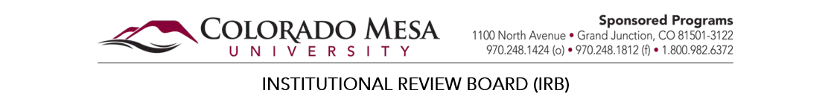

MODIFICATION REPORT FORM

Instructions

Modifications include but are not limited to changes in: investigators or research personnel, purpose/scope of research, recruitment procedures, compensation, subject population, and/or data collection procedures.

SECTION A: General Information

OVERVIEW Answer Required
- Protocol Number:
- Title of Protocol:
- Type of Review:
- Study Status:
Enrollment open, participant(s) active in research intervention.
Enrollment open, no participant(s) currently active in research intervention. Enrollment closed, participant(s) active in research intervention.
Enrollment closed, research limited to follow‐up only. Enrollment closed, research limited to data analysis only. Other, please explain:

INVESTIGATORS Answer Required
- Principal Investigator (PI) (Please refer to the Human Subjects policy on PI Roles & Responsibilities. Graduate Students PI’s must have a Faculty member/Administrator as a Co‐PI. Undergraduate Students cannot be PI’s.)
Name: Status: Telephone:
Institutional Email: Department:

SECTION B: Proposed Modifications

MODIFICATIONS
- Will the modification(s) require a change to any appendices (e.g., informed consent, survey materials, recruitment materials, etc.)? Answer Required
No
Yes: If yes, attach appropriate documents.
Attach Documents
View Attachment(s)
- Will the modification(s) increase any risks or present any new risk (i.e., physical, economic, or psychological)? Answer Required
No
Yes: If yes, provide an explanation.

- Will the modification(s) involve a change in personnel (PI, Co‐PI) or other key personnel? Answer Required
No
Yes: If yes, attach the Additional Investigators Form.
Attach Additional Investigators Form
View Attachment(s)

- Will the modification(s) involve a change of dates (i.e., Start Date & End Date)? Answer Required
No
Yes: If yes, complete the information below, and provide an explanation.

Original Start Date: New Start Date:
Original End Date: New End Date:

- Please list and provide an explanation for any other modifications?

SECTION C: Investigator Assurance and Acknowledgement

PRINCIPAL INVESTIGATOR

I certify that the information I provided in the Request for IRB Review is correct and complete. I also pledge that I will not change any of the procedures, forms, or protocols used in this study without first seeking review and approval from the Institutional Review Board. Answer Required

Name / Signature of Principal Investigator Date
All fields marked as ‘Answer Required’ must be completed before you can submit a protocol to the Colorado Mesa University IRB.
Attach Other Documents
View Attachment(s)

Submit

OFFICIAL OFFICE USE ONLY
Date Received: | Notes:
Protocol Number:
Reviewer:
Date Reviewed:
Revised: June 2019

