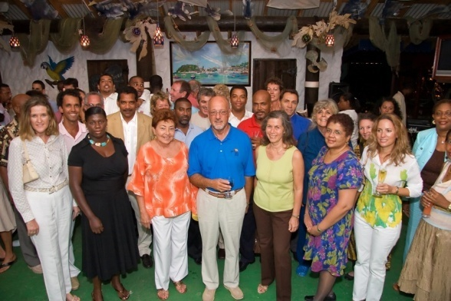

# Full Report Inside

# Event Report Contents

An Event Funding Pre-requisite is that the Event Organizer is required to prepare an Event Report upon the conclusion of the event and forward this report to the Mariachi Tourism Industry Advisory Board (MTIAB) within 28 days of the event’s conclusion. MTIAB requests that the Event Organizer prepares an event report using the contents headings listed below to format the report. This will allow the Events Sub Committee of MTIAB to assess each report in relation to the contents and ensures that the relevant information required to evaluate an event is received.

**Business Event Report**